**RoboColumbus-Plus Competition**

**(rule version – 20210313)**

**Objective:** Three orange cones, designated as home, target, and challenge, are placed outdoors approximately 100 yards from each other. The course between the home cone and the target cone is clear of obstacles. The course between the challenge cone to both the home cone and the target cone contains at least one obstacle that requires the robot to deviate from a direct path. The challenge is to touch and stop at each cone.

**Acknowledgement:** The inspiration for this contest is the SRS RoboMagellen competition. RoboColumbus-Plus is a simpler competition designed to build the outdoor robot building and navigation skills of the contest participants.

**Robot:** Competing robots must run autonomously and be self-contained. Robot size is limited to a size less than 48x48x60 inches (width, length, height) at the contest run start and until the robot moves greater than 1 yard. Maximum robot weight is 65 pounds. Robots must be designed to not damage the environment of the course. Robots must demonstrate an operational safety switch mechanism that can stop the robot in the event of an emergency. The robot may not split into multiple parts, but it may change shape after moving 1 yard. Robot must be propelled by electrical motors.

**Robots Owner**: If a robot is a team effort they must designate one person as the one who can make decisions as the robot’s owner.

**Self-Contained Definition:** Self-contained means that all computing power used to run the robot is carried on the robot platform. Radio can be used to collect run data, implement a safety switch mechanism, and obtain GPS or RTK-GPS data, but not to otherwise guide or control the robot.

**Run Definition:** A run starts when the robot is placed at the starting line of the course and is given a signal from the judge. The run ends when either the robot touches and stops at all 3 cones, runs out of time, malfunctions, or the judge declares the run to have ended. The judges may end the run if a robot either becomes stuck or trapped in a location by obstacles or has stopped moving for greater than 45 seconds. The robot owner is responsible for declaring that a robot has malfunctioned. The time limit per run is 15 minutes. Each robot is allowed 1 run per contest round. Once the robot moves 1 yard, it is considered to have participated in that run.

**Round Definition:** A round consists of a single run by each competing robot. The competition consists of 3 rounds. If you are not able to start your robot in any round, a fourth catchup round will be run at the end of the normal 3 rounds to allow everyone to attempt at least 1 run. Any runs after the four official rounds will not be scored for the contest.

**Play:** A set of three GPS coordinates will be available on the day of the contest. The coordinates will be labeled “home cone”, “target cone” and “challenge cone”.

At least 30 minutes before the first run starts the judges will place the cones anywhere within a 10-yard circle surrounding each of the designated coordinates. This is analogous to setting the “pin” in a “green” on a golf course. The judges will also mark a starting line.

During this time before the completion runs begin, the competitors are allowed onto the course to assess potential issues and to take measurements, collect data or gather waypoint readings. No one may modify the course or its surroundings with beacons or reflectors or other navigational aids, with the exception of a RTK-GPS base station.

Robots are not allowed on the course before the competition. There is no restriction on the equipment used to gather course information before a run, but it must not be attached to your robot while data collection is being performed. The data collection equipment may later be connected to the robot if it fits in the initial 48x48x60 envelope. Practice cones will be setup to allow contestants to test their robot on similar terrain to the competition course before the event.

A five-minute period will occur between each round to allow contestants to re-collect data on the course parameters or to recapture GPS waypoints. No changes will be made to the course between each round.

At the start of each run, the robot's owner places the robot ‘behind’ the starting line, which will be located near the home cone. The robot may be turned to any angle when initially placed. If a safety switch is used, the switch is handed to a neutral party who is knowledgeable in its operation. If a leash is being used, the contestant will hold the leash. At the start signal from the judge, the robot may start towards the target cone. The robot’s run is timed.

No one may place themselves or any objects in front of the robot during a run. No object or person should approach within 10 yards of a robot during a run except for the safety mechanism operator.

The safety mechanism operator may select a series of positions that minimizes the amount of walking needed to pace the robot. The safety mechanism operator is expected to be able to follow the robot at a comfortable pace. The safety mechanism of fast robots must have sufficient radio range to allow the safety mechanism operator to keep up. If the speed of the robot, the range of the safety switch radio, and the pace of the safety mechanism operator interact to cause the robot to stop, the run clock continues. If a leash is being used, the leash must remain slack during the entire run.

Use of GPS or RTK-GPS radio is allowed. The GPS receiver must be located on the robot.

The robot must remain in contact with the ground during the complete run.

**Beacon Definition:** Any object (including a person) that is added to the course or surrounding area, other than the robot, that actively or passively provides information to the robot is considered a beacon. If the safety mechanism is a leash the leash holder must walk behind the robot at least 3 feet and no more than 10 feet.

**Cone:** The cone used in the competition is approximately 17 inches high and is approximately 7 inches at the base of the cone. The cone sits on a black 10-inch square base. The height of the cone and base is approximately 18 inches. The color of the cone is “traffic cone orange”. The cone and cone base are both considered the cone. Touching the cone base is equivalent to touching the cone.

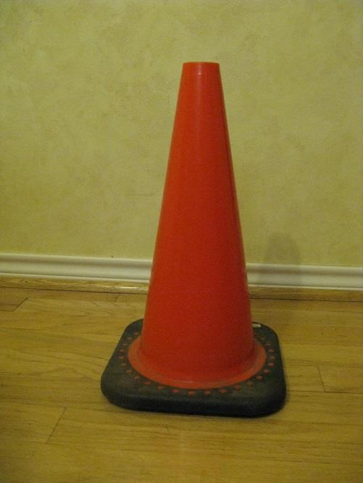

**Competition Cone**

**Robots on the course:** The judges may stagger the runs of robots so that more than one robot is on the course at the same time. Multiple robots running at the same time will only be used if the number of entrants is such that the 3 rounds cannot be completed in less than 5 hours.

Judges will not start a subsequent robot’s run unless they are confident the preceding robots will not interfere with the subsequent robot’s run. If the subsequent robot gets within 25 yards of the any of the preceding robots, the subsequent robots owner may decide to use the safety mechanism to pause the robot and the clock will stop until the preceding robots clear the contest area or the subsequent robot’s owner decides to restart the robot.

**Scoring:** Points are rewarded for the completion of the following tasks:

If a robot passes within 10 feet of a cone (includes touching the cone and not stopping), it receives 1 point.

If a robot stops within 10 feet of a cone for at least 5 seconds, it receives 2 points.

If a robot touches the cone and stops while touching the cone for least 5 seconds, it receives 3 points.

A maximum of three points per cone can be scored. The robot must score points from either the target cone or the challenge cone before approaching the home cone for points.

The distance from the cone is defined as the distance between the closest robot part and the cone.

A perfect contest run requires the robot to touch and stop while touching the cone for at least 5

seconds at each orange cone for a total score of 9.

The winning robot is determined by comparing the best run scores of each robot. If there is a tie in score, the robot with the shortest run time wins. Second and third place are determined in a similar manner.

**Penalties:** If the base of the cone is physically moved when the robot touches the cone a penalty of 2 minutes is added to the run time. If the cone is toppled, a penalty of 8 minutes is added to the run time.

**Course:** The course is outdoors and may have both natural and manmade terrain. The course may be wet from rain. Between the home and target cone, the course will not contain any obstacle that requires routing the robot away from a direct path. The course between the challenge cone to both the home cone and the target cone will have at least one obstacle that requires the robot to deviate from a direct path. The terrain may contain hills and dips but will not contain a water obstacle. Terrain may be chosen that obscures the view of cones from other cones, such as a hill. The straight inline distance between the start line and the target cone will be between 100 and 110 yards. The straight-line distance between the challenge cone and the other cones will depend on the contest location. The distances will be targeted to be between 75 and 150 yards.

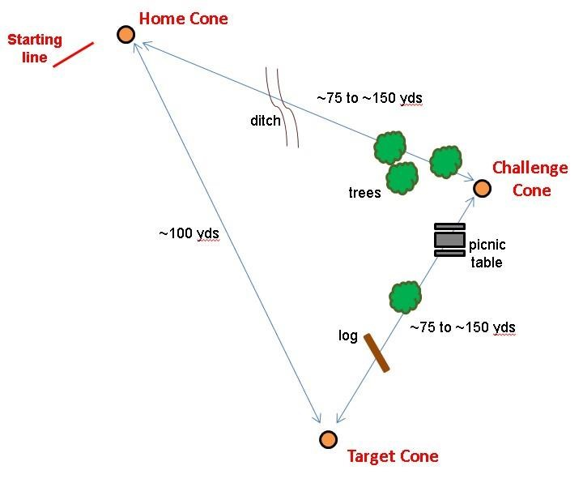

Example RoboColumbus-Plus course layout – not to scale

**Judging:** One or more judges will referee the contest. They will ensure the rules are followed and impose scoring penalties or remove a robot from competition if the robot is operating in an unsafe manner or not complying with the rules. The decisions of the judges are final.

**Safety:** If the behavior of a robot is determined to be unsafe, the judge will withdraw the robot from the competition. All competitors must demonstrate the ability to perform an emergency stop of their robot. The emergency stop is not required to switch off power to the robot but demonstrate that the robot can be reliably brought to a halt. This may be accomplished with a radio-controlled safety switch or by a rope tether to the robot with the competitor walking behind the robot holding the tether. The decisions of the judges regarding safety matters are final.

**Safety Switch Definition:** A safety switch is a switch that when engaged (limit type) or disengaged (dead man type) will stop the robot. If a radio-controlled switch is used, the robot must stop if it exceeds the range of the radio. If a tether is used pulling on the tether will cause the robot to stop. The switch must be of the momentary contact type.